**Drones and their Specifications.**

**1. Zipline P2**

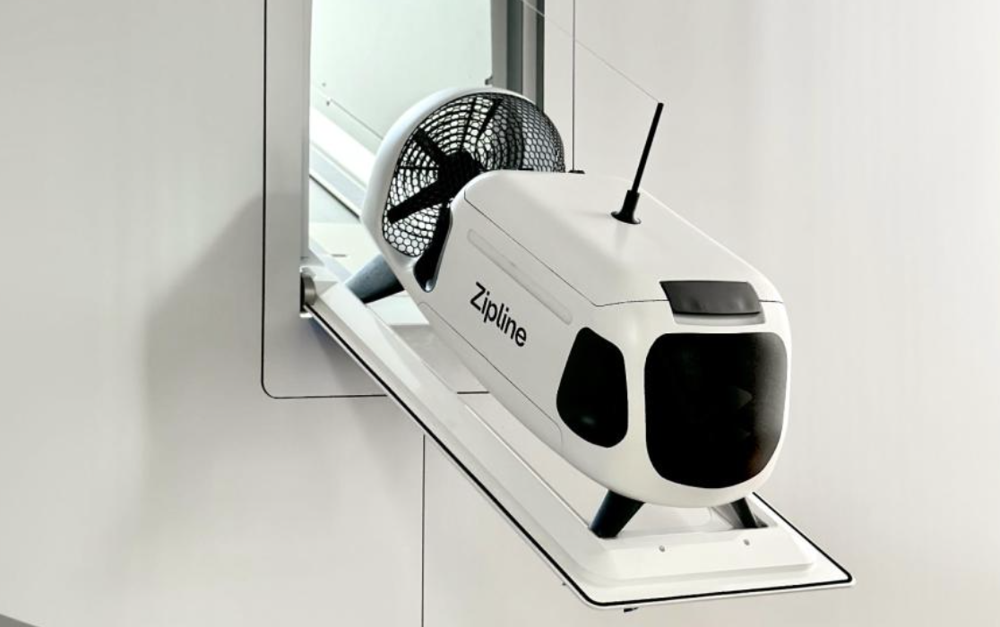

This is an autonomous delivery drone made for precise deliveries. It is quieter than other drones and it can fly more than 300 feet above the ground. The Zipline P2 can also fly up to 16 km one way from one location to another. They can also be charged at each location.

The P2 drone can deliver up to 7 times faster than traditional automobile delivery, completing 10-mile deliveries in about 10 minutes. It is also designed to be easy to load and unload, with a loading portal that allows each Zip to be loaded in seconds.

Overall, the Zipline P2 drone is a significant improvement over previous generations of Zipline drones. It is faster, quieter, and more precise. This makes it well-suited for a wide range of delivery applications, from healthcare to e-commerce.

**2. Vayu X5**

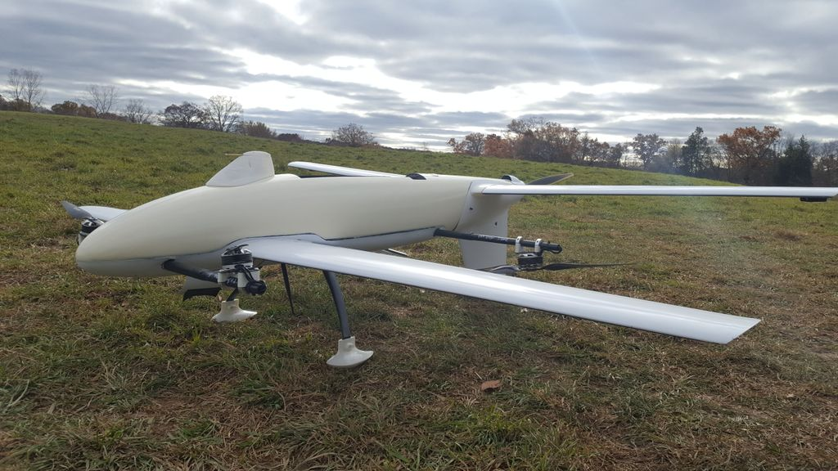

The Vayu X5 is a heavy-lift drone designed for a variety of applications, including cargo delivery, search and rescue, and disaster relief. It is capable of carrying payloads of up to 100 kg over distances of up to 10 km. The X5 is equipped with a variety of safety features, including an automatically-deployed parachute and a multi-factor 3D geofence.

The X5 is still under development, but it is expected to be released in 2023. Vayu Aerospace has not yet announced any customers for the X5, but it is likely to be of interest to a wide range of businesses and organizations.

**3. Google Wing**

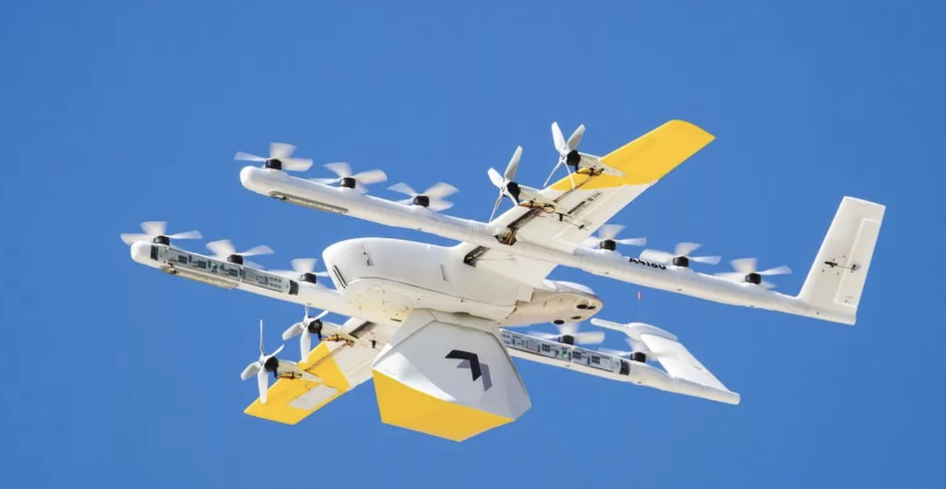

Google Wing is a subsidiary of Alphabet that is developing and deploying autonomous drone delivery services. Wing's drones are designed to deliver a variety of goods, including food, medicine, and packages, to customers in a safe and efficient manner.

Wing has been operating commercial drone delivery services in Australia, Finland, and the United States since 2019. The company has partnered with a variety of businesses, including Walgreens, Domino's Pizza, and FedEx, to deliver goods to customers.

Wing's drones are equipped with a variety of safety features, including redundant flight control systems, collision avoidance systems, and parachutes. The drones are also monitored by a team of human operators who can intervene if necessary.

The wing is committed to making drone delivery safe and reliable. The company is working with regulators and other stakeholders to develop the necessary infrastructure and regulations to support the safe and widespread deployment of drone delivery services.

**4. Skydio 2+ Healthcare Edition**

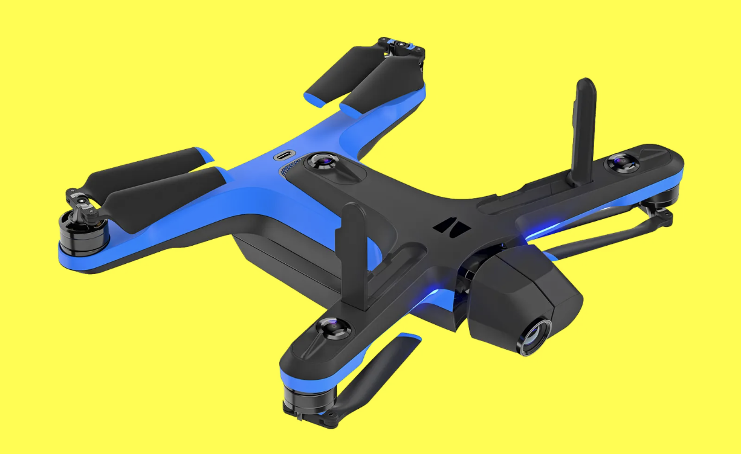

The Skydio 2+ Healthcare Edition is a specialized version of the Skydio 2+ drone that is designed for use in healthcare settings. It includes a number of features that make it ideal for use in demanding and complex environments, such as hospitals, clinics, and disaster zones.

The Skydio 2+ Healthcare Edition uses Skydio's proprietary obstacle avoidance system to safely navigate through complex environments, even in the presence of people, objects, and other obstacles.

The Skydio 2+ Healthcare Edition includes a high-resolution thermal imaging camera that can be used to detect and track people, objects, and other heat signatures in low-light or even no-light conditions.

The Skydio 2+ Healthcare Edition is integrated with Bard, a large language model from Google AI. This allows users to control the drone and view its footage using voice commands.

Compliance with HIPAA and other regulations: The Skydio 2+ Healthcare Edition is designed to comply with HIPAA and other healthcare regulations. This ensures that the drone's footage is protected and that patient privacy is maintained.

The Skydio 2+ Healthcare Edition is a valuable tool for healthcare professionals who need to safely and efficiently collect data and images in complex and challenging environments.

**5. Drone Delivery Canada Sparrow**

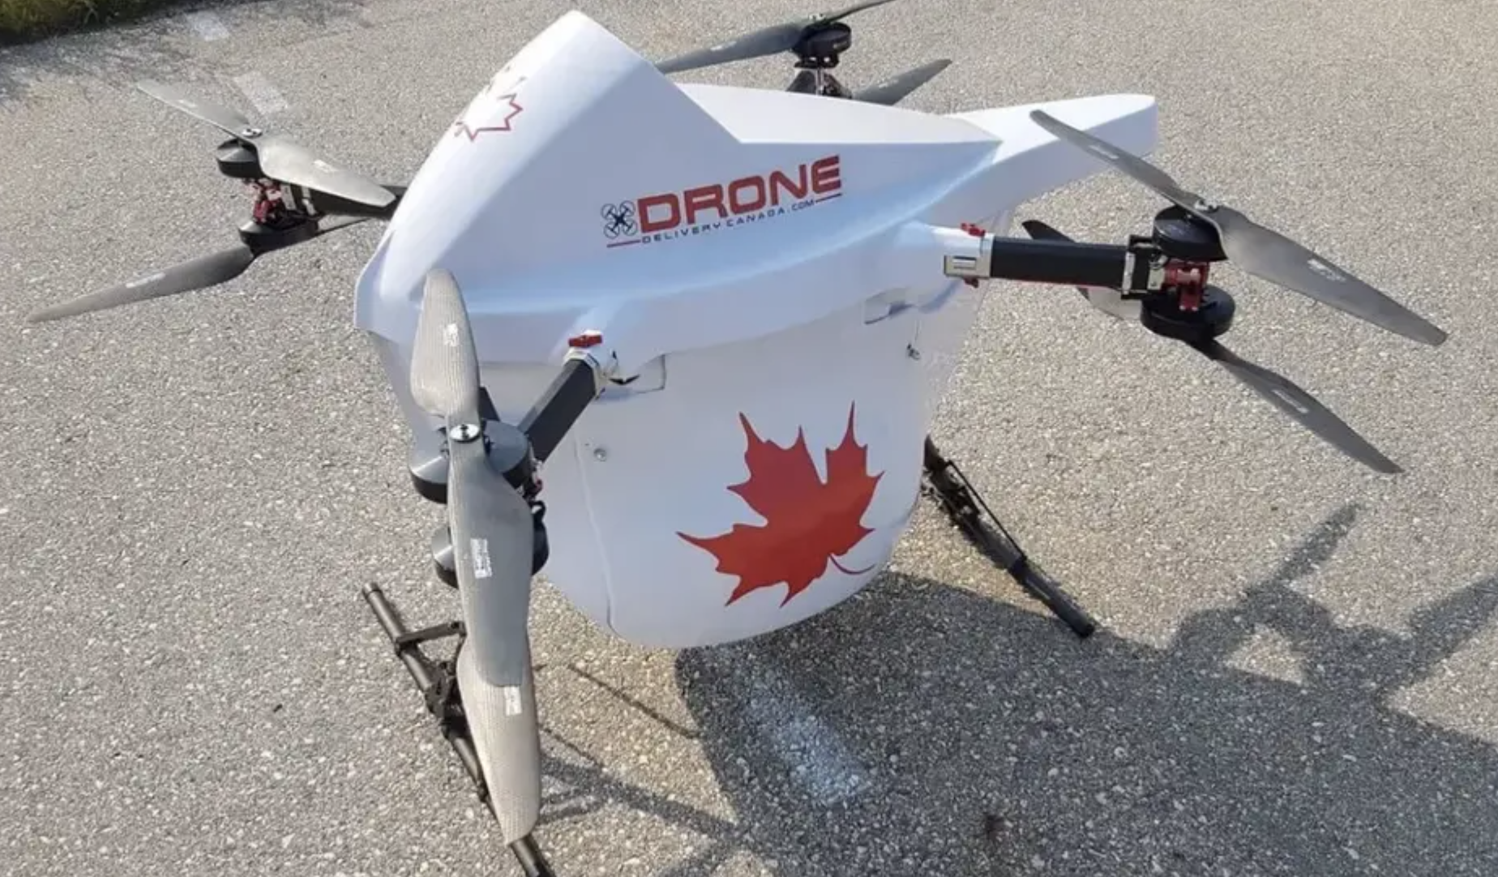

The Drone Delivery Canada Sparrow is a fixed-wing drone that is designed for autonomous delivery of cargo. It has a payload capacity of up to 4 kg and a range of up to 20 km. The Sparrow is equipped with a variety of safety features, including a redundant flight control system, a parachute system, and a collision avoidance system.

The Sparrow is a promising new drone technology for autonomous delivery. It has the potential to revolutionize the way goods are delivered, especially in remote or underserved areas.

The Sparrow is also notable for its ability to fly over people and other obstacles, which makes it suitable for delivery in urban areas. It is also equipped with a proprietary software system (FLYTE) that monitors air traffic, weather, obstacles, and other elements along the way. This ensures that the Sparrow can operate safely and reliably in a variety of environments.

**6. Flyability Elios 3**

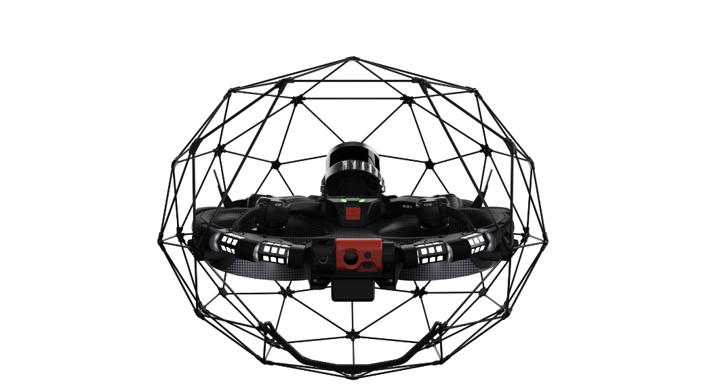

The Flyability Elios 3 is a collision-tolerant drone that is designed for indoor inspection and mapping. It has a spherical protective cage that allows it to fly safely in confined spaces, even in the presence of obstacles. The Elios 3 is equipped with a LiDAR sensor that can create 3D models of its surroundings, which can be used to identify defects and hazards.

The Flyability Elios 3 is a valuable tool for businesses that need to inspect and map their indoor assets safely and efficiently. It can help businesses to identify defects and hazards, and to make informed decisions about maintenance and repairs.

**7. EHang 184**

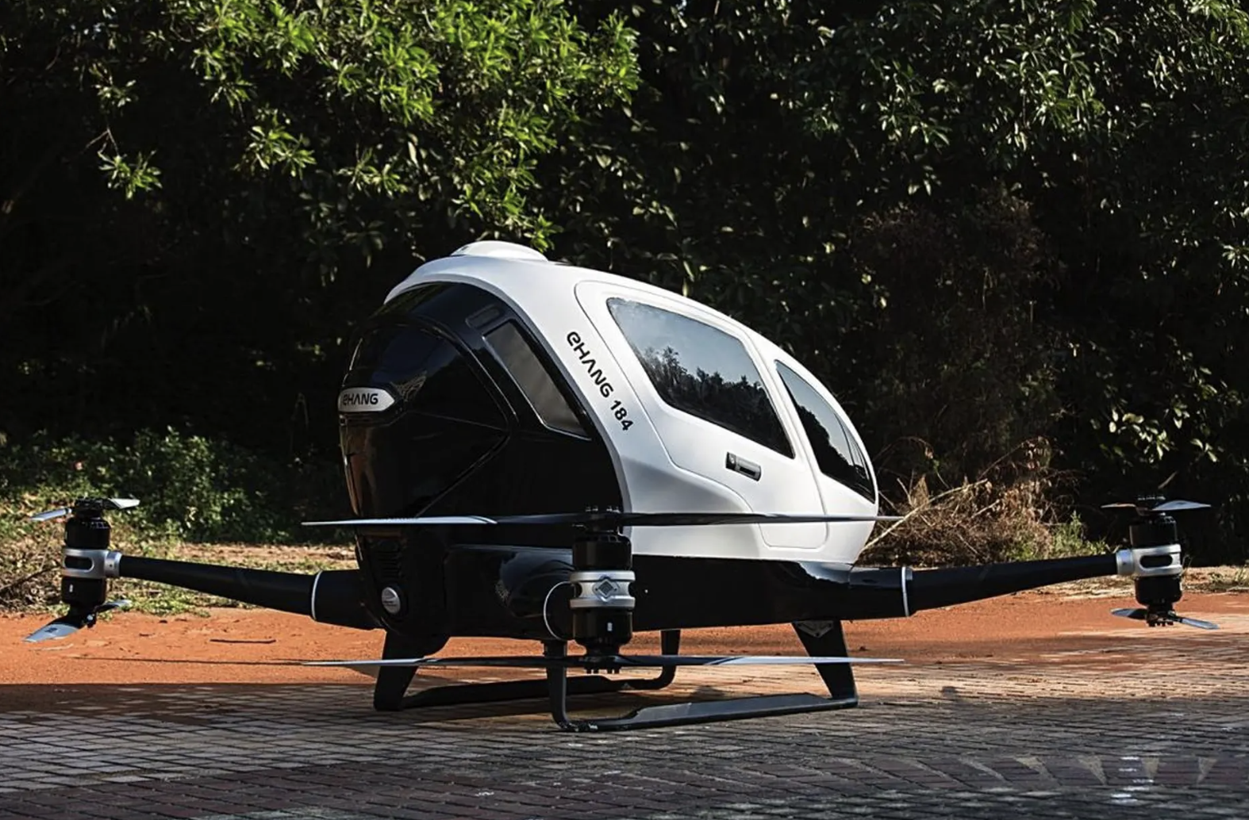

The EHang 184 is a passenger-grade autonomous aerial vehicle (AAV) designed for urban air mobility (UAM). It is a single-passenger, electric vertical take-off and landing (eVTOL) vehicle that can fly at speeds of up to 130 km/h and has a range of up to 250 km.

The EHang 184 is equipped with a variety of safety features, including a redundant flight control system, a parachute system, and a collision avoidance system. It is also designed to be easy to operate, with a simple touchscreen interface that allows passengers to select their destination and the EHang 184 will automatically fly them there.

The EHang 184 is still in the development stage, but it has already been tested in a variety of environments, including urban areas, rural areas, and even mountainous terrain. EHang is currently working with partners to develop commercial applications for the EHang 184, such as passenger transportation, logistics, and emergency response.

The EHang 184 is a promising new technology for urban air mobility. It has the potential to revolutionize the way people travel and deliver goods in cities.

**8. Wingcopter 198**

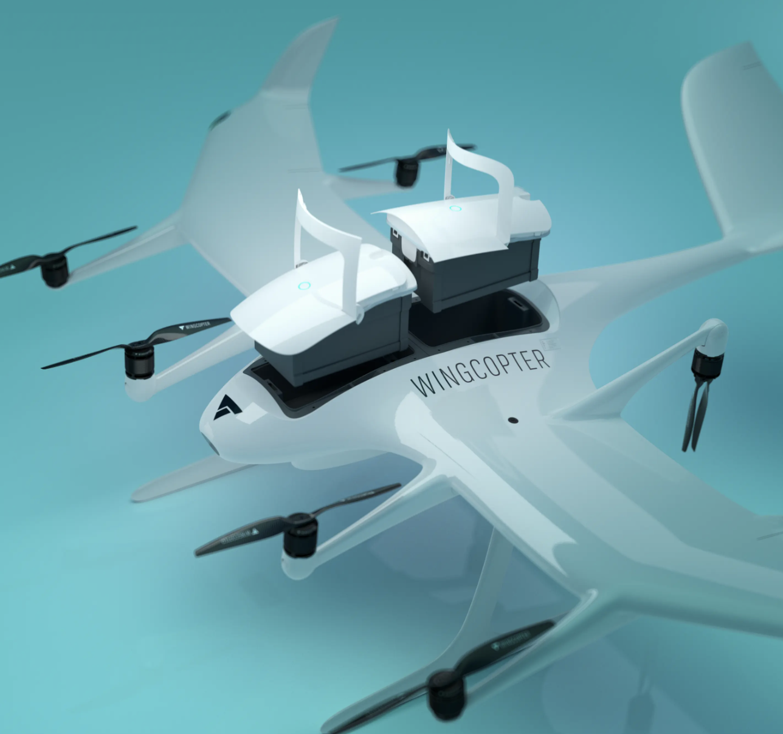

The Wingcopter 198 is a versatile all-electric, vertical-take-off-and-landing (eVTOL), fixed-wing drone that is designed for autonomous delivery and logistics applications. It has a unique design with eight rotors that can be tilted to transition between vertical and fixed-wing flight. The Wingcopter 198 can fly up to 90 minutes on a single battery charge and has a range of up to 220 kilometers. This makes it ideal for delivering goods to remote or underserved areas. The Wingcopter 198 can fly in winds of up to 20 meters per second and in temperatures ranging from -20 to 45 degrees Celsius. Also, this makes it suitable for use in a variety of weather conditions, including coastal and offshore environments. The Wingcopter 198 is designed for level 4 autonomous flying and deliveries. This means that it can take off, fly to its destination, deliver its payload, and land without any human intervention. This reduces the cost of operations and makes it easier to scale up delivery operations. The Wingcopter 198 can deliver up to three separate packages to multiple locations with a total weight of 5 kilograms during one single flight. This makes it ideal for delivering critical supplies to multiple locations in a single trip.

The Wingcopter 198 is currently undergoing FAA-type certification in the United States and is expected to be commercially available in 2023. Delivering medical supplies and blood samples to remote or underserved areas. Delivering e-commerce packages to customers in urban and rural areas. Providing disaster relief and humanitarian aid. Conducting environmental monitoring and inspection. The Wingcopter 198 is a significant advance in drone technology and has the potential to revolutionize the way goods are delivered.

**9. M2**

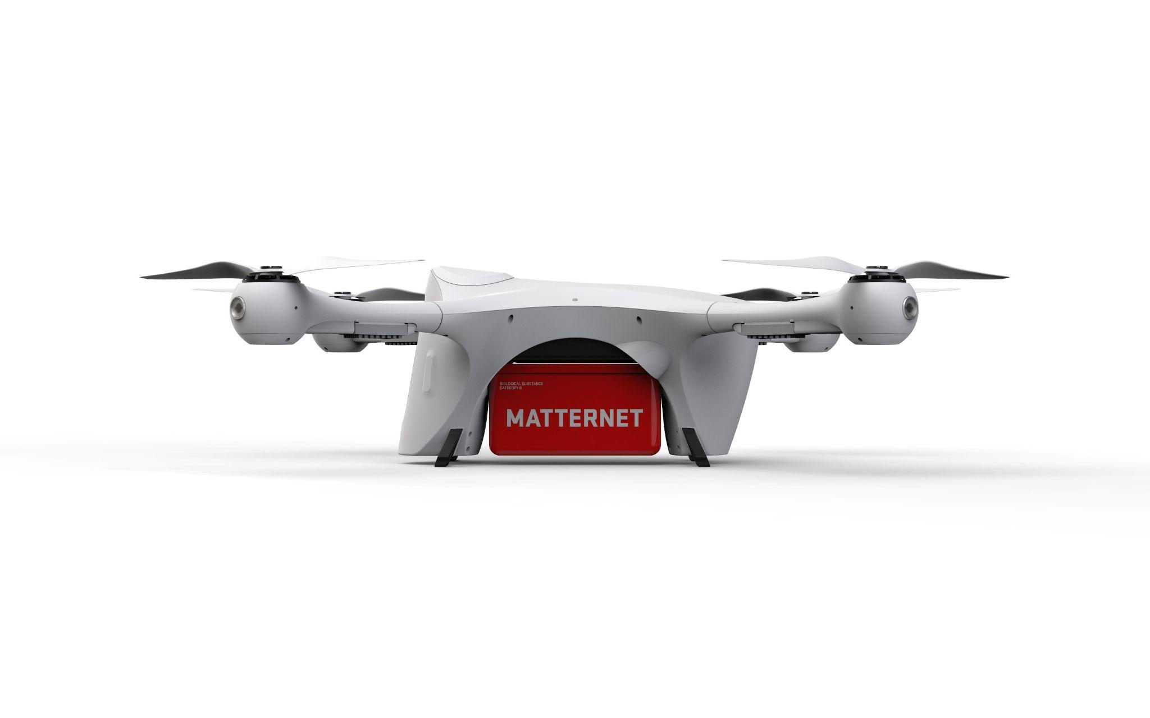

The Matternet M2 is a quadcopter drone that was released in 2019. It is designed for last-mile delivery applications in urban areas. The M2 is capable of carrying payloads of up to 2 kg over distances of up to 12.5 km (8 miles). It is equipped with a variety of safety features, including an automatically deployed parachute and a multi-factor 3D geofence.

The Matternet M2 is a versatile drone that can be used to deliver a wide variety of items, including food, groceries, medical supplies, and packages. It is also well-suited for use in a variety of environments, including urban areas, rural areas, and disaster zones.

The Matternet M2 is a quadcopter drone, meaning that it has four rotors. This gives the drone a high degree of stability and control. The drone is also equipped with a variety of sensors, including a GPS receiver, an inertial measurement unit (IMU), and an altimeter. These sensors allow the drone to navigate autonomously and safely.

The Matternet M2 can carry payloads of up to 2 kg. This makes it capable of delivering a wide variety of items, including food, groceries, medical supplies, and packages.

The Matternet M2 has a range of up to 12.5 km (8 miles). This gives it the ability to deliver items to customers in both urban and rural areas.

The Matternet M2 is equipped with a variety of safety features, including an automatically deployed parachute and a multi-factor 3D geofence. The parachute is designed to deploy automatically if the drone detects a problem, such as a loss of power or a collision. The 3D geofence prevents the drone from flying into restricted areas.

Overall, the Matternet M2 is a safe, reliable, and versatile drone that is well-suited for last-mile delivery applications. It is one of the first drones to be approved by the Federal Aviation Administration (FAA) for commercial use in the United States.

**10. Eagle**

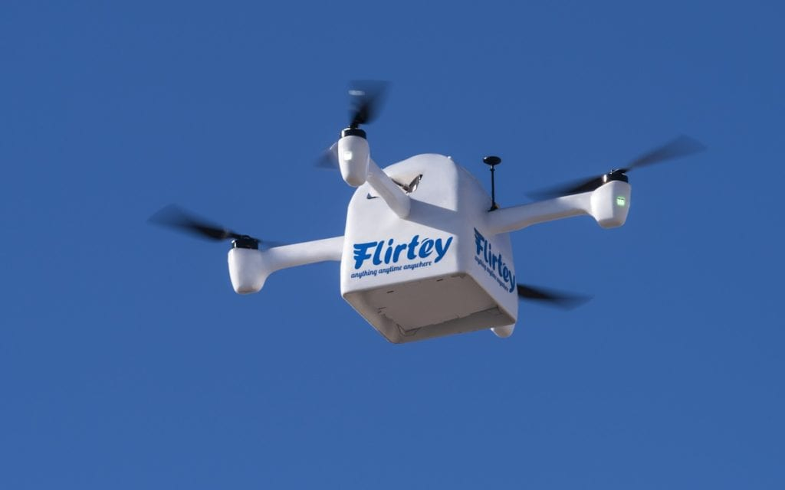

The Eagle Flirtey is a hexcopter drone, meaning that it has six rotors. This gives the drone a high degree of stability and control. The drone is also equipped with a variety of sensors, including a GPS receiver, an inertial measurement unit (IMU), and an altimeter.

These sensors allow the drone to navigate autonomously and safely. The Eagle Flirtey can carry payloads of up to 6.8 kg. This makes it capable of delivering a wide variety of items, including food, groceries, medical supplies, and packages. The Eagle Flirtey has a range of up to 10 km. This gives it the ability to deliver items to customers in both urban and rural areas. The Eagle Flirtey is equipped with a variety of safety features, including an automatically deployed parachute and a multi-factor 3D geofence. The parachute is designed to deploy automatically if the drone detects a problem, such as a loss of power or a collision. The 3D geofence prevents the drone from flying into restricted areas.

Overall, the Eagle Flirtey is a safe, reliable, and versatile drone that is well-suited for last-mile delivery applications.

Additionally, the Eagle Flirtey is one of the first drones to be approved by the Federal Aviation Administration (FAA) for commercial use in the United States. This makes it a valuable tool for businesses that are looking to implement drone delivery programs.

**11. Parcelcopter**

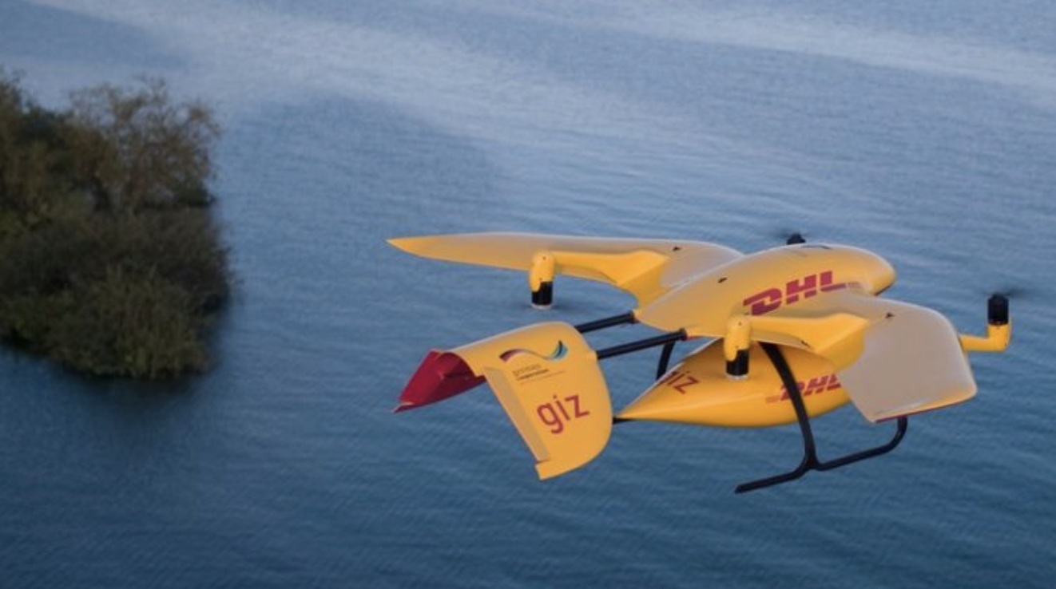

The DHL Parcelcopter 4.0 was first released in 2018. It is a tilt-rotor drone that can perform vertical take-offs and landings but then transition to a more energy-efficient fixed-wing flight. This allows it to fly up to 37 miles (60 km) at a speed of up to 62 mph (100 km/h). The Parcelcopter 4.0 can carry up to 13 pounds (6 kg) of payload.

In 2018, DHL and Wingcopter conducted a successful test flight of the Parcelcopter 4.0, delivering a package to a remote island in Lake Victoria, Tanzania. This was a major milestone for DHL, as it showed that the Parcelcopter 4.0 could be used to deliver goods to remote areas that are not accessible by traditional transportation methods.

DHL has not yet announced a commercial launch date for the Parcelcopter 4.0, but it is expected to be used for a variety of applications, including delivering medical supplies, blood samples, and other critical items to remote or underserved areas.

**12.MD4-3000**

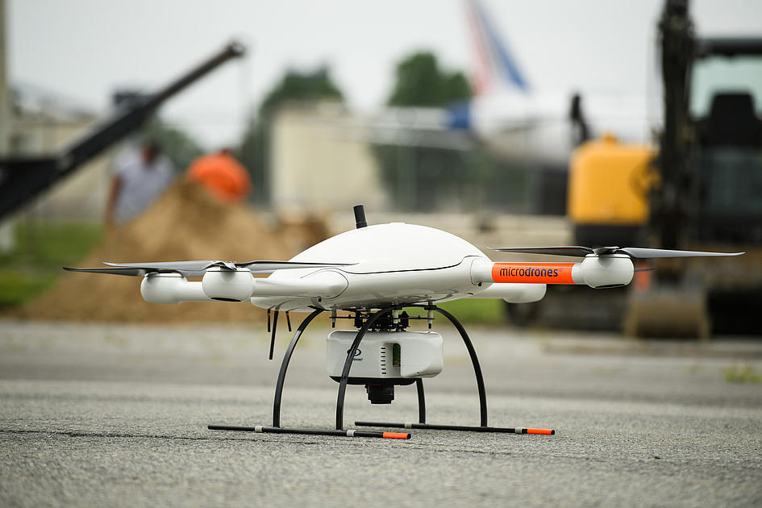

The Microdrones md4-3000 is a professional multi-rotor drone that was released in 2018. It is designed for a variety of applications, including aerial photography, surveying, and mapping. The md4-3000 is equipped with a high-resolution camera and a variety of sensors, and it is capable of flying in demanding weather conditions.

The md4-3000 is also highly autonomous. It can be programmed to fly pre-defined missions, and it can avoid obstacles using its onboard sensors. This makes it ideal for applications such as surveying and mapping, where the drone needs to fly over a large area and collect data autonomously.

The md4-3000 is a quadcopter drone, meaning that it has four rotors. This gives the drone a high degree of stability and control. The drone is also equipped with a variety of sensors, including a GPS receiver, an inertial measurement unit (IMU), and an altimeter. These sensors allow the drone to navigate autonomously and safely. The md4-3000 can carry payloads of up to 3 kg. This makes it capable of carrying a variety of equipment, including high-resolution cameras, LiDAR scanners, and other sensors. The md4-3000 has a range of up to 5 km. This gives it the ability to fly over large areas and collect data.

The md4-3000 has a flight time of up to 36 minutes. This is sufficient for most aerial photography, surveying, and mapping missions.

Safety features: The md4-3000 is equipped with a variety of safety features, including a return-to-home function and a low-battery warning system.

Overall, the md4-3000 is a powerful and versatile drone that is well-suited for a variety of professional applications. It is easy to operate and provides high-quality data.

**References**

“Building the Future of Autonomous Delivery.” Technology | Zipline Drone Delivery &amp;

Logistics, www.flyzipline.com/technology. Accessed 7 Sept. 2023.

Kesteloo, Haye. “Deliver Future: DHL Parcelcopter Flies 37 Miles Autonomously to a

Remote Island in Lake Victoria.” DroneDJ, 11 Oct. 2018,

dronedj.com/2018/10/10/deliver-future-dhl-parcelcopter/.

“Wingcopter 198 – Wingcopter.” Wico_with_type_black, wingcopter.com/wingcopter-198.

Accessed 7 Sept. 2023.

“UAM - Passenger Autonomous Aerial Vehicle (AAV).” EHang, www.ehang.com/ehangaav. Accessed 7 Sept. 2023.

Wpmd. “Get the Latest Drone Technology from Drone Delivery Canada.” Drone Delivery

Canada, 11 Sept. 2021, dronedeliverycanada.com/technology/.

“Digitizing the Inaccessible.” Elios 3, www.flyability.com/elios-3. Accessed 7 Sept. 2023.

Wing, wing.com/. Accessed 7 Sept. 2023.

“Skydio 2+ Drone - Skydio Inc..” Skydio, www.skydio.com/skydio-2-plus-enterprise.

Accessed 7 Sept. 2023.

“Flirtey (SkyDrop): Flirtey Is the World’s First Commercial Drone Delivery Service And...”

*Y Combinator*, www.ycombinator.com/companies/flirtey. Accessed 20 Sept. 2023.

Straight, Brian. “Flirtey Firing up Production, Taking Preorders for Delivery Drone.”

FreightWaves, 5 Mar. 2021,

[www.freightwaves.com/news/flirtey-firing-up-production-taking-preorders-for-delive](http://www.freightwaves.com/news/flirtey-firing-up-production-taking-preorders-for-delive)

ry-drone.

Flirtey. “Flirtey to Certify and Expand Production of the Flirtey Eagle Drone Delivery

System.” PR Newswire: Press Release Distribution, Targeting, Monitoring and

Marketing, 4 Mar. 2021,

[www.prnewswire.com/news-releases/flirtey-to-certify-and-expand-production-of-the-](http://www.prnewswire.com/news-releases/flirtey-to-certify-and-expand-production-of-the-)

flirtey-eagle-drone-delivery-system-301240669.html.

Vayuaerospace, vayuaerospace.com/. Accessed 20 Sept. 2023.

“Microdrones - MD4-3000 - Drones - Heavy Lifting Drone by Microdrones GmbH.”

Microdrones - Md4-3000 - Drones - Heavy Lifting Drone By ...,

[www.environmental-expert.com/products/microdrones-model-md4-3000-heavy-liftin](http://www.environmental-expert.com/products/microdrones-model-md4-3000-heavy-liftin)

g-drone-634962. Accessed 20 Sept. 2023.

*Matternet*, www.mttr.net/. Accessed 20 Sept. 2023.

“On-Demand Delivery Platform.” *Matternet*, www.mttr.net/product. Accessed 20 Sept. 2023.

Levin, Alan. “First Delivery Drone Matternet’s Model M2 Granted Design Approval by

FAA.” *Bloomberg.Com*, Bloomberg, 7 Sept. 2022,

[www.bloomberg.com/news/articles/2022-09-07/first-delivery-drone-granted-design-a](http://www.bloomberg.com/news/articles/2022-09-07/first-delivery-drone-granted-design-a)

pproval-by-us-regulators.